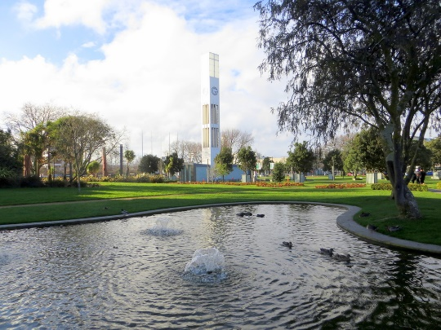
A Brief History
Rebus NZ Inc was established
in 2015 when the majority of
Probus Clubs in NZ voted to
Become independent of the
Australian governing body.

Our Club is now in its xxth
Year since formation and
in 201x, became an affiliate
of Rebus NZ Inc, a New
Zealand accreditation agency
for the former Probus Clubs.

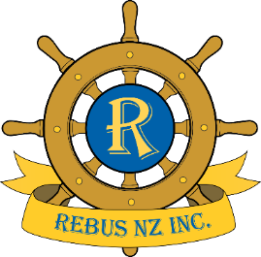

Contacts
President
Ima First 06 xxxxxxxxxx

Vice President
Ima Second 06 xxxxxxxxxx

Secretary
Ivor Wright 06 xxxxxxxxxx

Treasurer
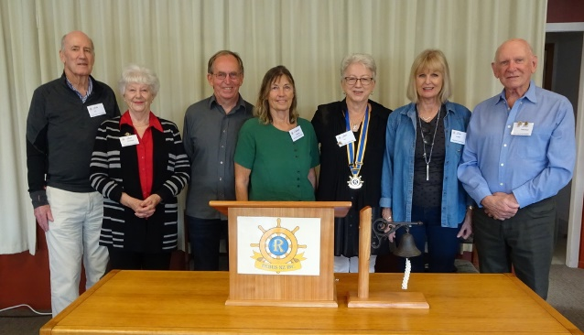
Robbie Bank 021 xxxxxxxxx

Club email address
info@xxxx.co.nz

Club Website
www.rebus-somewhere.nz
Rebus Club
of
Somewhere
We meet at the xxxxxxxxxxxx
46 Smith Street on the xxxx
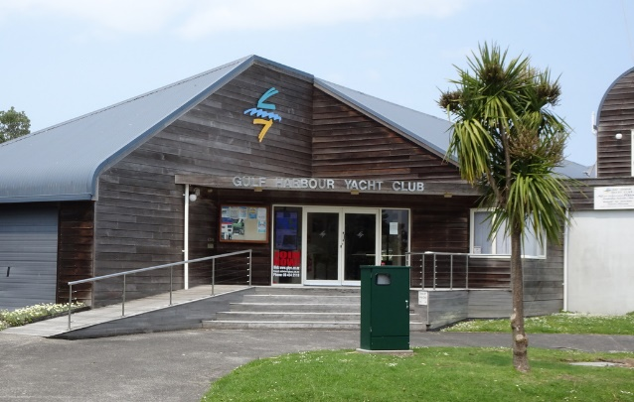
day of each month.
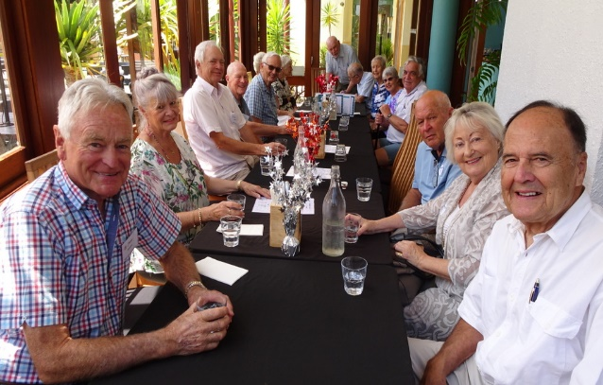
The word REBUS is a joining of the words REtired and Business.

Rebus is an association of Active “Seniors” who join together by forming Clubs. This provides regular occasions to keep minds active, expand interests and enjoy the ready fellowship and convivialIty of new friends.
Types of Clubs: There are Men’s Clubs, Women’s Clubs and Combined Clubs. Our Club is a XXXXXXXXXX Club.

Meetings are held on the xx xx day of the month
commencing at 10.00am until noon.

Luncheons are held mid-year and end of year for members and their partners.

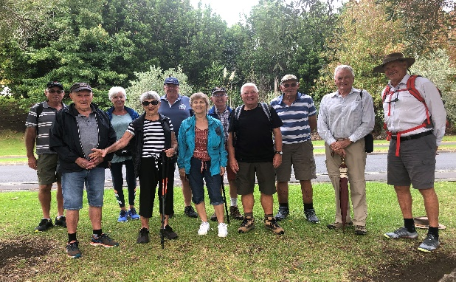
Membership fees for our Club are currently $xx per annum plus a $xx joining fee.
Membership
Members are encouraged to participate in as many Club activities as possible. They are optional—not compulsory.
*Perhaps give a 10 minute talk.
*join an interest group run
within the Club such as walking,
movies, travel, Bridge, Mahjong,
wine appreciation, dining and
books.
*Introduce or thank Speakers.
*Introduce friends as prospective
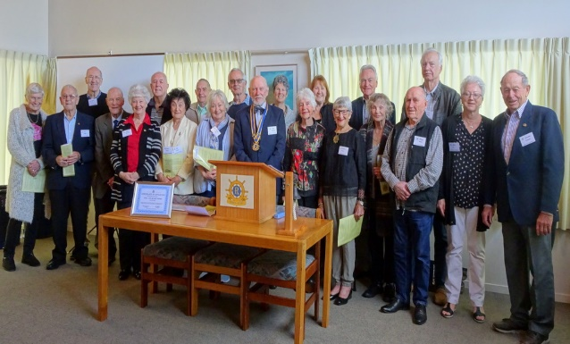
Members.

